The effect of climate change on changing the frequency of the transverse air waves pattern over Iraq during the winter season
By
Marwa Sattar Jabbar
Department of Geography/ College of Education for Human Sciences/University of Thi-Qar/ Thi-Qar/ 64001/Iraq
Email: marwhsattar@mail.com
Prof.Dr. Aziz Kouti Hussein
Department of Geography/ College of Education for Human Sciences/University of Thi-Qar/ Thi-Qar/ 64001/Iraq
Email: Dr.aziz.g@utq.edu.iq
Introduction
Comprehensive climatic studies are considered the most important fields because they have a clear role in knowing the climatic weather conditions and their reflection on various human activities. The Earth's surface, especially the temperatures, and the process of influence and influence between the upper pressure levels and the surface pressure levels of the gaseous envelope. Accordingly, the researcher in the comprehensive climate focuses on studying climate phenomena through spatial and temporal identification and the pressure level through which they move and knowledge of their recurrence and general climatic characteristics of them, these characteristics The climatic effects of which began to be clear after the occurrence of the industrial revolution in the nineteenth century, which contributed significantly from that time until the present time to an increase in the proportion of greenhouse gases, the most important of which is carbon dioxide (Co2), whose quantities began to exacerbate significantly, and it is a result of the increased use of energy. And the consumption of fossil fuels (coal, oil and gas), as well as the high levels of methane and gases Others called greenhouse gases and by the action of human activities, which led to a defect in the composition of the gaseous envelope and the emergence of many environmental problems, the most important of which is the problem of climate change that affected the elements and climatic phenomena. The upper pressure, including the pressure level (500) millibars, through which the transverse air waves move.
Second: The research problem: What is the extent of the effect of climatic changes in changing the frequency of the transverse air waves pattern over Iraq?
Third: Research Hypothesis: Climate change has an effect on changing the frequency of the transverse air waves pattern over Iraq.
Fourth: Research Objective: The research aims to analyze and find out the impact of climate changes on changing the frequency of transverse air waves over Iraq within the pressure level of 500 millibars.
Fifth: Research Limits: Research is determined by two dimensions:
1- The spatial dimension: Iraq is located in the southwestern part of the continent of Asia, between two latitudes
(-5 °29 - -22 °37) N and in arcs of longitude (-45 °38 - -45 °48) E. Map (1)
Map (1) The location of Iraq from latitude and longitude circles
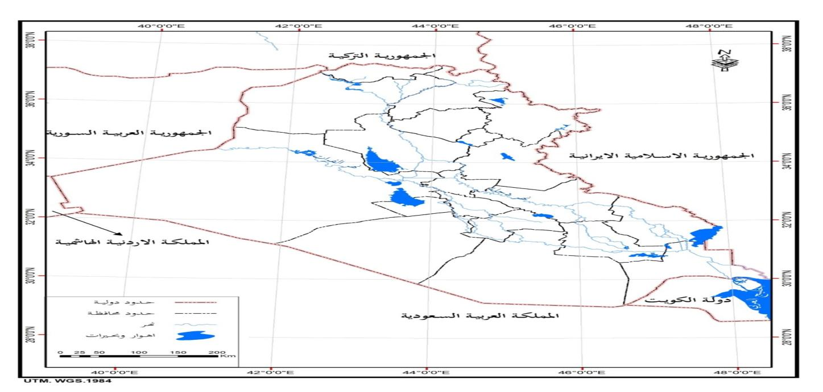
Source: Ministry of Water Resources, General Directorate of Survey, Iraq Map, Baghdad, 2007
The temporal dimension:
Three climatic cycles were chosen:
The first climatic cycle 1950-1961
The second climate cycle 1990-2001
The third climate cycle 2010-2021
In which the frequency of transverse air waves within the barometric level of 500 mbar was analyzed and the amount of change for each cycle during the winter months was found for each region of Iraq.
Sixth: Research methodology: The research relied on the inductive analytical method in analyzing the daily weather maps for the barometric level of 500 millibar to record the frequency of the transverse air waves during the study period of the transverse air waves for the night observation (00Z) and the daytime observation (012), i.e. at three o’clock in the morning and three o’clock in the afternoon According to the local time, depending on the Internet and the site on which the weather maps are published, represented by the National Oceanic and Gaseous Administration (NOAA) website (www.esrl.noaa/pasd/data/composites) and then showing the frequency rates of transverse air waves for each month The winter season and showing the rate of each climatic cycle and putting it in the tables that represented the main tables that were worked on and extracting the amount of change for recurrence rates in each month and for each climatic cycle and according to the northern, central and southern regions of Iraq using the moving media method (A Verage Moving) Al-Asadi and Al-Nasser / 2005 / p. 308) which are as follows:
S_{t} =$\frac{\sum_{i=t}^{t-N-1}{Xi}}{N}$
t is the observation time period
x represents the observation at time
n is the size of the studied sample
S_{t} =$\frac{\sum_{i=t}^{t-N+1}{Si}}{N}$
whereas
St is The single moving media
Si is The double moving circles
Seventh: An entrance to the transverse air waves: It is one of the types of air waves that take the transverse pattern at the pressure level of 500 millibars and are called transverse waves because they extend with latitude circles. Map (2) as a result of the presence, weakness or lack of energy exchange between the tropical region and the polar region (Al-Qadi / 2007 / p. 161).
Eighth: Changing the frequency of the transverse air waves pattern over Iraq during the winter season:
1- December: The transverse air waves witnessed an increase in the change in frequency in December. Map (3) Table (1) and Figure (1) show that the amount of change in the northern region amounted to (0.68+) and reached (0.81+) in the central region. (0.96+) in the southern region, and the highest frequency of transverse waves recorded in the third climatic cycle (5.09) waves for each of the northern, central and southern regions, while the lowest frequency was recorded in the first cycle at a rate of (4.0) waves in northern and central Iraq and (3.81) waves. wave in the southern region.
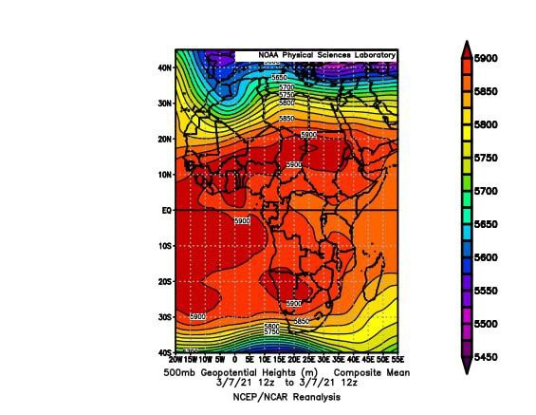
Map (2) The extension of the transverse pattern of air waves :https://www.esrl.noaa.gov/psd/data/composites/hoursource
Map (3) The extension of the transverse wave over Iraq in December
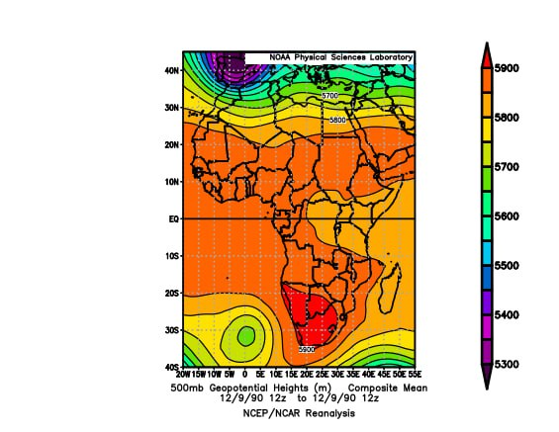Source ://www.esrl.noaa.gov/psd/data/composites/hour
Table (1) The average frequency of transverse air waves in December for the climatic cycles (2010/2021-1990/2001-1950/1961) for the observation (00z)
climatic cycles | northern area | Central area | Southern area
1950-1961 | 4.0 | 4.0 | 3.81
1990-2001 | 4.27 | 4.54 | 4.45
2010-2021 | 5.09 | 5.09 | 5.09
amount of change | 0.68+ | 0.81+ | 0.96+
Source: the table from the researcher's work based on the analysis of the weather maps for the pressure level (500 millibars) published on the Internet on the site:
https://www.esrl.noaa.gov/psd/data/composites/hour
Figure (1) The frequency and trend of transverse air waves in December for the climatic cycles (2010/2021-1990/2001-1950/1961) for the observation (00z)
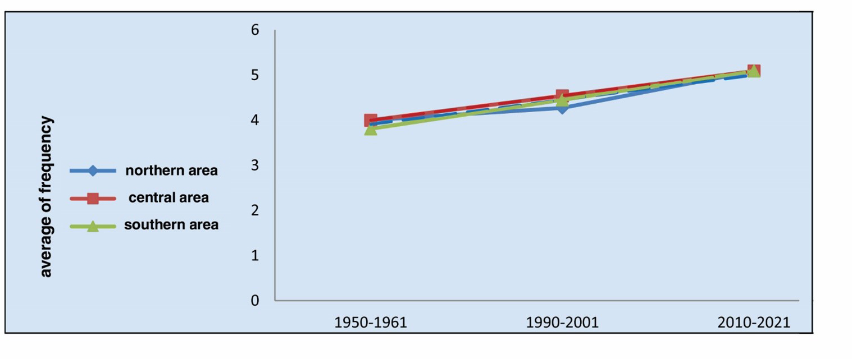

Source: From the researcher's work based on Table (1).
As for the daytime observations, the trend towards positive change is observed in Table (2) and Figure (2). In the northern region, it amounted to (1.96+), which recorded the lowest frequency of (5.0) waves in the third cycle, and in the central region, the amount of change amounted to (1.68+). ) and the highest frequency was recorded in the second cycle (4.72) wave, while in the southern region the change in frequency was (2.36+) and the highest frequency was (5.27) wave in the second cycle. As for the lowest recurrence rate in all regions of Iraq, it was witnessed in the first cycle, as it reached (2.90) waves for each of the northern and central regions, and it reached (2.63) waves in the southern region. It is clear from the foregoing that although the transverse air waves tended to change in all regions of Iraq during the month of December, this change was greater in the southern region and less in the northern region, especially during night observations, and the reason for this is determined by the increase in the activity of thermal energy exchange during the night. , Which helps to deepen the air canyons over northern Iraq, which are usually the first to enter them, so they are more influential than central and southern Iraq (Al-Nouri / 2009 / p. 26).
Table (2) The average frequency of transverse air waves in December for the climatic cycles (2010/2021-1990/2001-1950/1961) for the observation (12z)
climatic cycles | northern area | Central area | Southern area
1950-1961 | 2.90 | 2.90 | 2.63
1990-2001 | 4.72 | 4.72 | 5.27
2010-2021 | 5.0 | 4.45 | 4.72
amount change | 1.96+ | 1.68+ | 2.36+
Source: the table from the researcher's work based on the analysis of the weather maps for the pressure level (500 millibars) published on the Internet on the site:
https://www.esrl.noaa.gov/psd/data/composites/hour
Figure (2) The frequency and trend of transverse air waves in December for the climatic cycles (2010/2021-1990/2001-1950/1961) for the observation (12z)
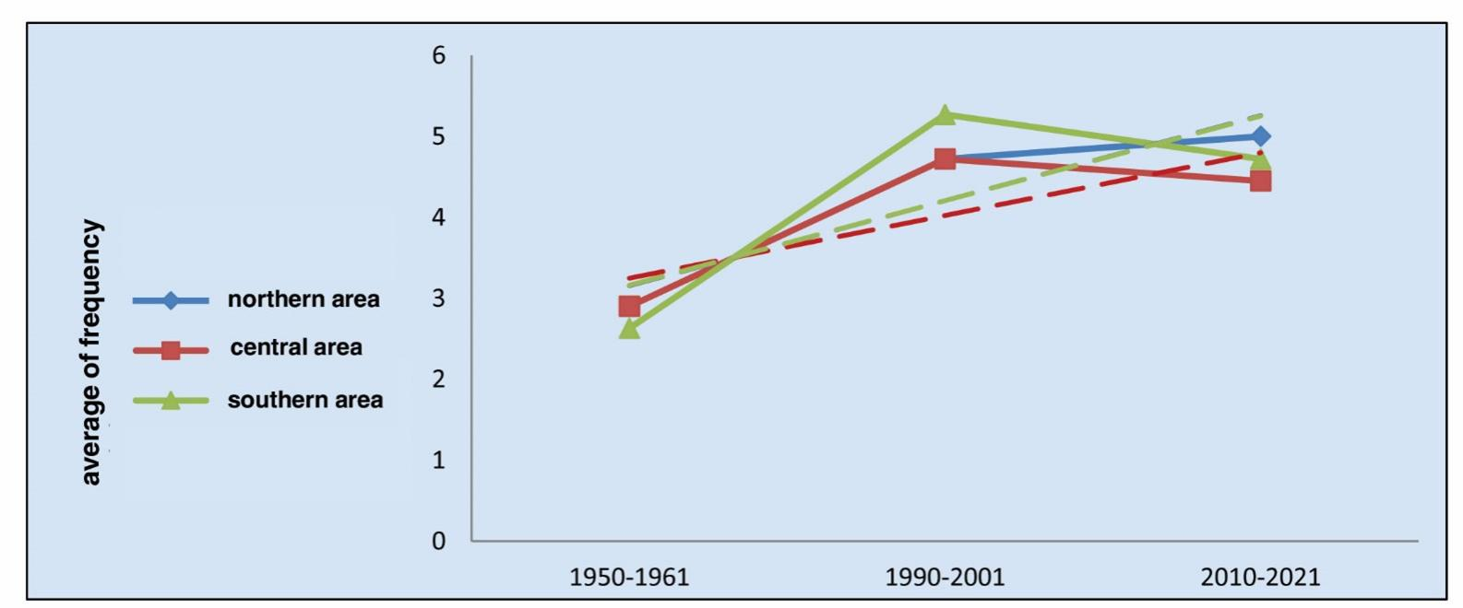

Source: from the researcher's work based on Table (2).
2- January:
From the observation of Table (3) and Figure (3), it is noted that the clear decrease in the frequency of transverse air waves during the month of January in the night observations, because the eruption of the upper polar systems of
Table (3) The average frequency of transverse air waves in January for the climatic cycles (2010/2021-1990/2001-1950/1961) for the observation (00z)
climatic cycles | northern area | Central area | Southern area
1950-1961 | 3.54 | 3.09 | 3.09
1990-2001 | 3.36 | 3.27 | 3.36
2010-2021 | 4.45 | 3.27 | 4.36
amount of change | 0.36+ | 0.18+ | 0.77+
Source: the table from the researcher's work based on the analysis of the weather maps for the pressure level (500 millibars) published on the Internet on the site:
https://www.esrl.noaa.gov/psd/data/composites/hour
Figure (3) The frequency and trend of transverse air waves in January for the climatic cycles (2010/2021-1990/2001-1950/1961) for the observation (00z
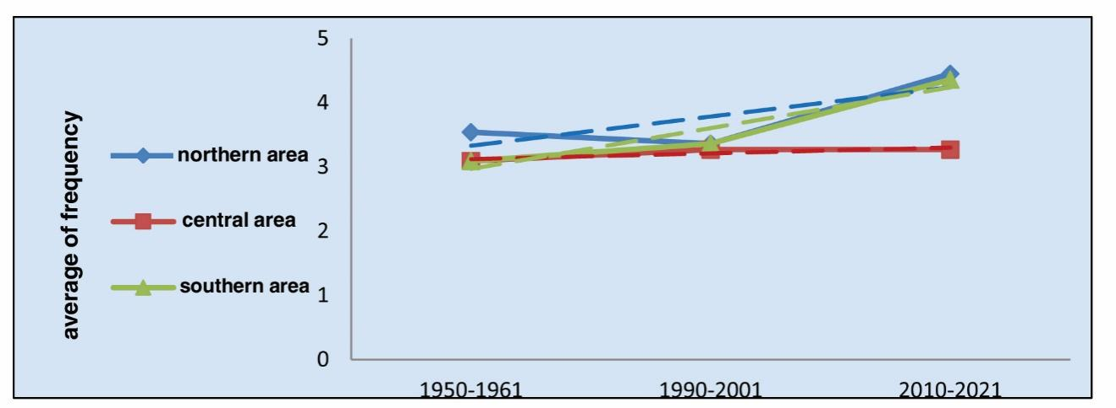

Source: From the researcher's work based on Table (3)
The upper northern latitudes lead to a clear prominence of air canyons and cut depressions, which usually increase in appearance in this month, due to the decrease in temperatures that allows more penetration towards the tropical region (Al-Shammari / 2007 / p. 42), but this does not mean that the amount of cross-sectional change is directed Towards contradiction, it recorded a positive trend in all the northern, central and southern regions of Iraq, because the climate change witnessed by the globe was reflected in the increase in its frequency change during the study period, and this is evident in the results of Table (3) and Figure (3) of the night observations, where the region was recorded The northern region showed a positive change, reaching (0.36 +), and the trend towards an increase also in central and southern Iraq, as it reached (0.18 +) in the central region and (0.77 +) in the southern region. The highest frequencies of transverse waves were recorded in the third cycle, which amounted to (4.45, 3.27, 4.36) waves, respectively, while the second cycle accounted for the lowest frequency in the northern region (3.36) waves, and the lowest recurrence rate for the central and southern regions in the first cycle (3.09) waves per who are they .
As for the daytime observations, they also witnessed a record decrease in recurrence rates compared to what was recorded in December, Table (4) and Figure (4), due to the growth of air canyons and cut depressions, where the upper air waves at the pressure level of 500 millibar usually tend to this pattern in January, which is the coldest month of the year (Al-Zinad / 2018 / p. 41).
Table (4) The average frequency of transverse air waves in January for the climatic cycles (2010/2021-1990/2001-1950/1961) for the observation (12z)
climatic cycles | northern area | Central area | Southern area
1950-1961 | 3.09 | 3.0 | 3.09
1990-2001 | 3.81 | 3.0 | 3.45
2010-2021 | 3.63 | 4.18 | 4.09
amount of change | 0.36+ | 0.59+ | 0.68+
Source: the table from the researcher's work based on the analysis of the weather maps for the pressure level (500 millibars) published on the Internet on the site:
https://www.esrl.noaa.gov/psd/data/composites/hour
With a decrease in the amount of change compared to the previous months, this change did not take a different direction, but was also positive. It was recorded in the northern region (0.36+) and with its highest frequency in the second cycle (3.81) waves, and in the central region the amount of change was (0.59+) and It reached (0.68+). The third cycle accounted for the highest recurrence rate in the central and southern regions (4.18, 4.09) waves, respectively, while the first cycle is the lowest in frequency, as it reached (3.09) waves in the north and (3.0) waves in the central and (3.09) waves in the south, and map (4) shows that Iraq was affected by the transverse pattern of air waves in January.
Figure (4) The frequency and trend of transverse air waves in January for the climatic cycles (2010/2021-1990/2001-1950/1961) for the observation (12z)
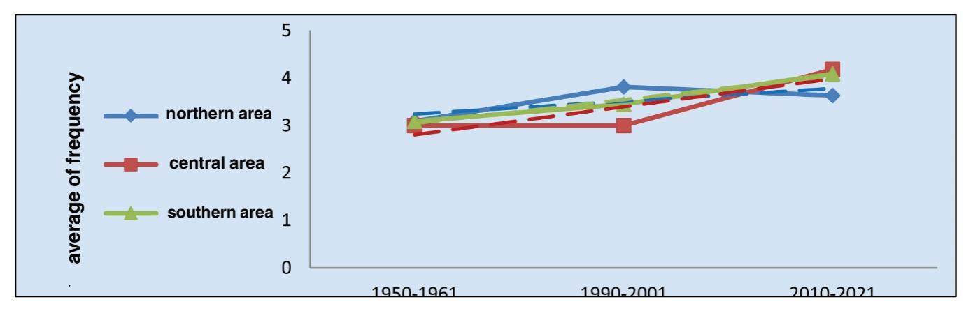

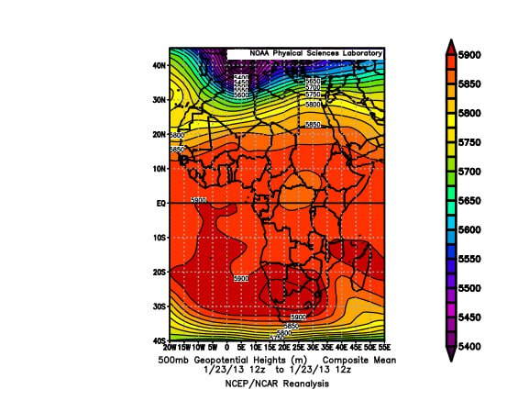
Source: https://www.esrl.noaa.gov/psd/data/composites/houhr
6- February:
The transverse air waves tended to increase in frequency in February during the night observations compared to what was recorded in January, because any decline in the polar air flow from the north leads to a weakening of the effect of the groove pattern of the upper air waves (Al-Jourani / 2013 / p. 113), and the tropical effects Which appear at the level of 500 millibars did not take its normal position, as its movement is often oscillating during this month between advance and retreat, which gives way to the emergence of transverse waves (Al-Husseinawi / 2010 / p. 172). Map (5).
Accordingly, the northern region took a positive trend in changing its frequency in the night observations, Table (5) and Figure (5), as it reached (1.82 +). The positive trend is divided into the central and southern regions by an amount of change (1.77 + 1.27), respectively. Recurrence rates among the climatic cycles, as it recorded (5.09) waves in the northern region, (4.81) waves in the central region, and (4.54) waves in the southern region, while the frequency of transverse air waves was the lowest in the first cycle (3.18, 2.72, 2.45) waves in Northern, central and southern Iraq
Table (5) The average frequency of transverse air waves in February for the climatic cycles (1961/2001-1950/2010/2021-2010/2021) for the observation (00z)
climatic cycles | northern area | Central area | Southern area
1950-1961 | 2.54 | 2.72 | 3.18
1990-2001 | 3.63 | 4.18 | 4.36
2010-2021 | 5.09 | 4.81 | 4.54
amount of change | 1.82+ | 1.77+ | 1.27+
Source: the table from the researcher's work based on the analysis of the weather maps for the pressure level (500 millibars) published on the Internet on the site:
https://www.esrl.noaa.gov/psd/data/composites/hour
The data of Table (13) and Figure (13) of the daytime observation show that the amount of change took an increasing trend.
It reached (0.90+) in the northern region, and the central region recorded an increasing trend as well (1.05 +) and the same was the case in the southern region (1.23+). The southern (4.18, 4.09) waves, respectively, and the lowest frequency was recorded in the first cycle, as it reached (3.18, 2.90, 2.81) waves, respectively, for the northern, central and southern regions of Iraq
Figure (5) The frequency and trend of transverse air waves in February for the climatic cycles (2010/2021-1990/2001-1950/1961) for the observation (00z)
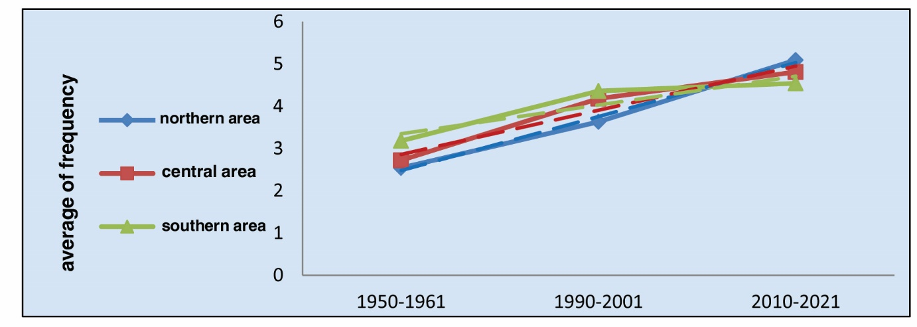

Source: From the researcher's work, based on Table (5).
Map (5) The extension of the transverse wave over Iraq in February
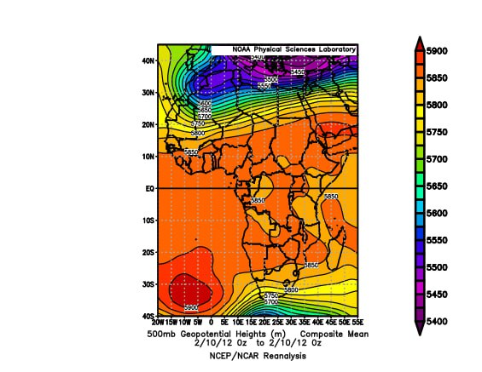
Table (6) The average frequency of transverse air waves in the month of February for the climatic cycles (2010/2021-1990/2001-1950/1961) for the observation (12z).
climatic cycles | northern area | Central area | Southern area
1950-1961 | 3.18 | 2.90 | 2.81
1990-2001 | 3.90 | 4.18 | 4.09
2010-2021 | 4.27 | 3.72 | 4.0
amount of change | 0.90+ | 1.05+ | 1.23+
Source: the table from the researcher's work based on the analysis of the weather maps for the pressure level (500 millibars) published on the Internet on the site:
https://www.esrl.noaa.gov/psd/data/composites/hour
Figure (6) The frequency and trend of transverse air waves in February for the climatic cycles (2010/2021-1990/2001-1950/1961) for the observation (12z)
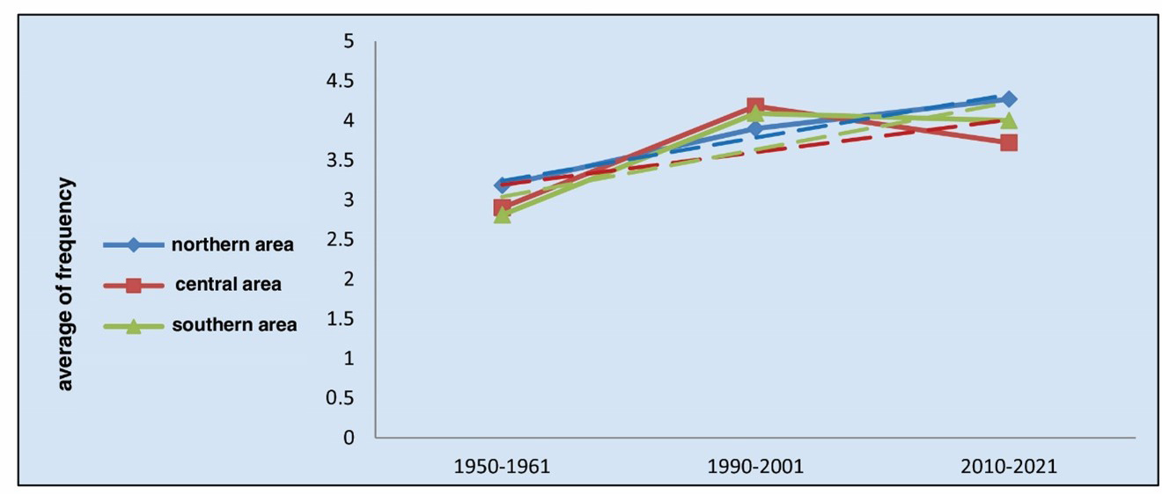

Source: from the researcher's work based on Table (6).
Conclusions
The research reached the following results:
- The change in frequency of transverse air waves turned positive in December in all regions of Iraq.
- The highest change in the frequency of the transverse wave was recorded in the month of December in the observation 0z in the southern region, which amounted to 0.96 +, and the lowest amount of change in the northern region was 0.68 +.
- The highest amount of change for the frequency of the transverse waves pattern in December in the observation 12z in the southern region was +2.36, and the least in the central region was +1.68.
- The amount of change recorded a positive trend in the month of January in the two observations (12z and 0z). The highest amount of change for the first observation was in the southern region +0.77 and the lowest in the central region +0.18.
- The southern region retained the highest amount of change in the balance 12z in January, reaching +0.68, and the least in the southern region +0.36.
- The amount of change recorded in the month of February was a positive change in the northern, central and southern regions of Iraq, and the highest amount of change was recorded in the northern region +1.82 and the lowest in the southern region +1.27 during the observation 0z.
- The highest amount of change was in the month of February in the observation 12z in the southern region, as it reached +1.23, and the lowest in February during this observation in the northern region was +0.90.
References
1- Al-Asadi, Kazem Abdel-Wahhab and Khadija Abdel-Nasser, Change in the duration of control of the secondary centers of the Siberian High and centers (secondary and main) of the Mediterranean depression during the rainy season over Iraq for the period 1950-2001, Maysan Research Journal, Volume 2, Issue 23, 2016.
2- Al-Jourani, Mansour Ghadban Yazaa, The effect of climate change on the change of the movement of furrows and winds and their impact on the climate of Iraq, Master thesis, Dhi Qar University, College of Arts, 2013.
3- Al-Husseinawi, Aziz Kouti Hussein, Characteristics of the phenomenon of air stagnation and its impact on the weather and climate of Iraq, PhD thesis, University of Baghdad, College of Arts, 2008.
4- Al-Husseinawi, Aziz Kouti Hussein, Analysis of the Frequency of Straight Air Waves Over Iraq, Journal of Dhi Qar Arts, Issue 2, 2010.
5- The Trigger, Shaimaa Sami Abdel-Hafez, The Impact of Climate Change on the Recurrence of the Highlands and Lows of Cutoff over Iraq, Master Thesis, University of Basra, College of Arts, 2018.
6- Al-Shammari, Hussein Jabr Wasmi, The repetition of the barometric barrier and its impact on the elements of the Iraqi climate, Master Thesis, University of Baghdad, College of Arts, 2007.
7- Al-Qadi, Taghreed Ahmed Omran Issa, The Impact of Thermal Depressions on Iraq’s Weather and Climate, PhD thesis, University of Baghdad, College of Arts, 2006.
8- Al-Nouri, Sulaf Adnan Jaber, The Impact of the Phenomenon of Furrows and Winds in Iraq's Weather and Climate, Ph.D. thesis, College of Education, Ibn Rushd, University of Baghdad, 2009.
9- Ministry of Water Resources, General Directorate of Survey, Iraq Map, Baghdad, 2007.
10-https://www.esrl.noaa.gov/psd/data/composites/hour.

